**BC COMMANDS:-**

1. bc ( about software ):-

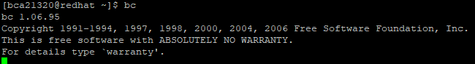

2. bc (as a calculator):-

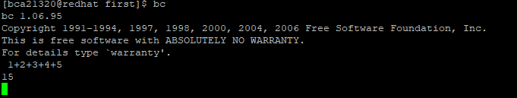

3. bc –q:- welcome messsage